Chapter Two: Graphics Hardware

Introduction
Graphics hardware is computer hardware that generates computer graphics and allows them to be shown on a display, usually using a graphics card (video card) in combination with a device driver to create the images on the screen. Graphic hardware can be divided into three major categories of devices:
- Input devices with which the user interacts to generate necessary instruction or data for creating graphics
- Display systems where the graphics are rendered on the monitor screen
- Hardcopy devices or printers through which the tangible graphics output is produced.
- ReadyImage (Scanner) Devices.

Input Hardware
A Graphics Input device is that is used to interact with or provide data to the computer. Various devices are available for data input on graphics workstations. The most common input devices are the mouse and keyboard. However, additional devices like trackball, spaceball, joysticks, digitizers, button boxes are specially designed for interactive input. Some other input devices used in particular applications are data gloves, touch panels, image scanners and voice systems.

Computer Graphics Hardware/devices can also be broadly classified as:-
- Locator device such as graphics tablet, touch panel, mouse, trackball, joystick, keyboard that indicates a position (e.g., point coordinate) or orientation. Locator devices can be classified as:
  - Absolute devices, for example, touch panel, have a reference frame or origin and the with respect position are reported with respect to this origin.

  - Relative index such as mouse have no absolute origin and report only changes from their previous position.
  - Direct devices such as light pen can be used as the user points at the screen directly with a finger or surrogate finger.
  - Indirect devices, for example, mouse allows user to move a cursor on the screen using a device, not directly interacting on the screen.
  - Continuous devices have the capability to create a smooth cursor motion, for example, mouse.
  - Discrete devices such as cursor control keys (up arrow, down arrow, etc.) do not offer smooth position change.
- Pick device such as the light pen, joystick, mouse that can select a graphical object,
- Valuator device such as joystick or trackball that are used to input scalar values such as rotation angle, scale factors etc.
- Keyboard or Text input device such as the typewriter type keyboard which has been in use for very long time. Sometimes, alphabetically organized keyboards are used by non-typists.
- Choice device such as the keyboard function keys, mouse, touch panel, voice systems that are used to select menu options.

Keyboard
With a Keyboard, a person can type a document, use keystroke shortcuts, access menus, play games and perform a variety of other tasks. Though keyboards can have different keys depending on the manufacturer, the operating system that they are designed for, and whether they are attached to a desktop computer or are part of a laptop. Most keyboards have between 80 and 110 keys, including:
- Typing keys (letters A to Z, a to z, characters like < , ? + = etc.)
- A Numeric keypad (numbers 0 to 9, characters like ! @ # ( ), etc.)
- Function keys (F1 to F12)
- Control keys (Ctrl, Alt, Del, Pg Up, Pg Dn, Home, End, Esc, Fn, arrow keys etc.)

Function keys allow users to enter frequently-used operations with a single keystroke and Control keys allow cursor and screen control. Displayed objects and menus can be selected using the Control keys. A keyboard is a lot like a miniature computer. It has its own processor, circuitry (key matrix) and a ROM storing the character map. It uses a variety of switch technology. Though the basic working technology is same there are design variations to make the keyboards easier and safer to use, versatile and elegant. Some of the non- traditional keyboards are Das keyboard, Virtual Laser keyboard, True-touch Roll-up keyboard, Ion Illuminated keyboard, and Wireless keyboard.
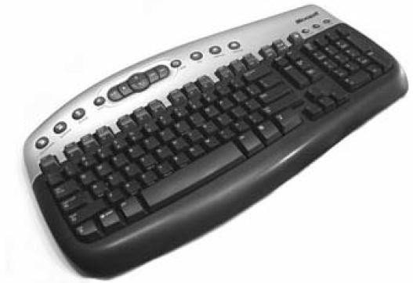
Figure 2.1: Microsoft Wireless Keyboard

Mouse
A Mouse is a hand-held pointing device, designed to sit under one hand of the user and to detect movement relative to its two-dimensional supporting surface. It has become an inseparable part of a computer system just like the keyboard. A cursor in the shape of an arrow or cross-hair always associated with a mouse. Users reach out for the mouse whenever they want to move the cursor or activate something or drag and drop or resize some object on display. Drawing or designing figures and shapes using graphic application packages like AutoCAD, Photoshop, CorelDraw, and Paint is almost impossible without mouse. The mouse’s 2D motion typically translates into the motion of a pointer on a display. In a Mechanical mouse, a ball – roller assembly is used; one roller used for

detecting X direction motion and the other for detecting Y direction motion. An Optical mouse uses LED and photodiodes (or optoelectronic sensors) to detect the movement of the underlying surface, rather than moving some of its parts as in a mechanical mouse. Modern Laser mouse uses a small laser instead of a LED. A mouse may have one, two or three buttons on the top. Usually clicking the primary or leftmost button will select items or pick screen-points, and clicking the secondary or rightmost button will bring up a menu of alternative actions applicable to the selected item or specific to the context. Extra buttons or features are included in the mouse to add more control or dimensional inputs.
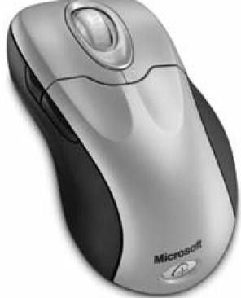
Figure 2.2: Microsoft’s Two-Button Wireless Mouse

Trackball
A Trackball is a pointing device consisting of a ball housed in a socket containing sensors to detect rotation of the ball about two axes—like an upside-down mouse with an exposed protruding ball. The user rolls the ball with his thumb, fingers, or the palm of his hand to move a cursor. A potentiometer captures the track ball orientation which is calibrated with the translation of the cursor on screen. Tracker balls are common on CAD workstations for ease of use and, before the advent of the touchpad, on portable computers, where there may be no desk space on which to use a mouse.

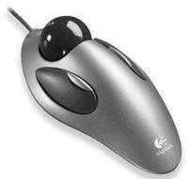
Figure 2.3: A Logitech Trackball

Joystick
A Joystick is used as a personal computer peripheral or general control device consisting of a hand-held stick that pivots about the base and steers the screen cursor around. Most joysticks are two-dimensional, having two axes of movement (similar to a mouse), but three-dimensional joysticks do exist. A joystick is generally configured so that moving the stick left or right signals movement along the X-axis, and moving it forward (up) or back (down) signals movement along the Y-axis. In Joysticks that are configured for three dimensional movement, twisting the stick left (counter-clockwise) or right (clockwise) signals movement along the Z-axis. In conventional joystick potentiometers, or variable resistors, are used to dynamically detect the location of the stick and springs are there to return the stick to centre position as it is released. In many joysticks, optical sensors are used instead of analog potentiometer to read stick movement digitally. One of the biggest additions to the world of joysticks is force feedback technology. If a force feedback (also called haptic feedback) joystick is used when shooting a machine gun in an action game, the stick would vibrate in your hands. Or if you crashed your plane in a flight simulator, the stick would push back suddenly which means the stick moves in conjunction with onscreen actions.
Joysticks are often used to control games, and usually have one or more push- buttons whose state can also be read by the computer. Most I/O interface cards for PCs have a joystick (game control) port. Joysticks were popular during the

mid-1990s for playing games and flight-simulators, although their use has declined with promotion of the mouse and keyboard.
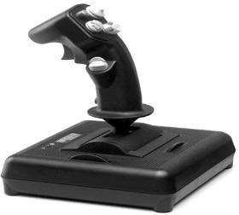
Figure 2.4: The Flighterstick, a Modern Programmable USB Joystick

Digitizer and Graphics Tablet
A Digitizer is a locator device used for drawing, painting, or interactively selecting coordinate positions on an object. Graphics tablet is one such digitizer that consists of a flat surface upon which the user may draw an image using an attached stylus, a pen-like drawing apparatus. The image generally does not appear on the tablet itself but, rather, is displayed on the computer monitor. The first graphics tablet resembling contemporary tablets was the RAND Tablet, also known as the Grafacon (for Graphic Converter). It employed an orthogonal grid of wires under the surface of the pad. When pressure is applied to a point on the tablet using a stylus, the horizontal wire and vertical wire associated with the corresponding grid point meet each other, causing an electric current to flow into each of these wires. Since an electric current is only present in the two wires that meet, a unique coordinate for the stylus can be retrieved. The coordinate returned are tablet coordinates which are converted to user or screen coordinates by imaging software. Even if it does not touch the tablet, proximity of the stylus to the tablet surface can also be sensed by virtue of a weak magnetic field projected approximately one inch from the tablet surface. It is important to note that, unlike the RAND Tablet, modern tablets do not require electronics in the stylus and any tool that provides an accurate ‘point’ may be used with the pad. In some tablets, a multiple button hand-cursor is used instead of stylus. Graphics tablets are available in various sizes and price ranges—A6-sized tablets being relatively inexpensive and A3-sized tablets being far more expensive.

Modern tablets usually connect to the computer via a USB interface. Because of their stylus-based interface and (in some cases) ability to detect pressure, tilt, and other attributes of the stylus and its interaction with the tablet, are widely used to create two-dimensional computer graphics. Free-hand sketches by an artist or drawing following an existing image on the tablet are useful while digitizing old engineering drawing, electrical circuits and maps and toposheets for GIS. Indeed, many graphics packages (e.g., Corel Painter, Inkscape, Photoshop, Pixel Image Editor, Studio Artist, The GIMP) are able to make use of the pressure (and, in some cases, stylus tilt) information generated by a tablet, by modifying attributes such as brush size, opacity, and color. Three dimensional graphics can also be created by a 3D digitizer that uses sonic or electromagnetic transmissions to record positions on a real object as the stylus moves over its surface.
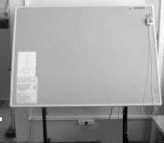

Figure 2.5: A Tablet with Hand Cursor

Touch Panel
A Touch panel is a display device that accepts user input by means of a touch sensitive screen. The input is given by touching displayed buttons or menus or icons with finger. In a typical optical touch panel, LEDs are mounted in adjacent edges (one vertical and one horizontal). The opposite pair of adjacent edges contains light detectors. These detectors instantly identify which two orthogonal light beams emitted by the LEDs are blocked by a finger or other pointing device and thereby record the x, y coordinates of the screen position touched for selection. However, because of its poor resolution, the touch panel cannot be

used for selecting very small graphic objects or accurate screen positions. The other two type of touch panels are electrical (or capacitive) and acoustical. In an electrical touch panel, two glass plates coated with appropriate conductive and resistive materials are placed face to face similar to capacitor plates. Touching a point on the display panel generates force which changes the gap between the plates. This in turn causes change in capacitance across the plates that are converted to coordinate values of the selected screen position. In acoustic type, similar to the light rays, sonic beams are generated from the horizontal and vertical edges of the screen. The sonic beam is obstructed or reflected back by putting a finger in the designed location on the screen. From the time of travel of the beams, the location of the fingertip is determined. Touch panels have gained wide acceptance in bank ATMs, video games and railway or tourist information systems.
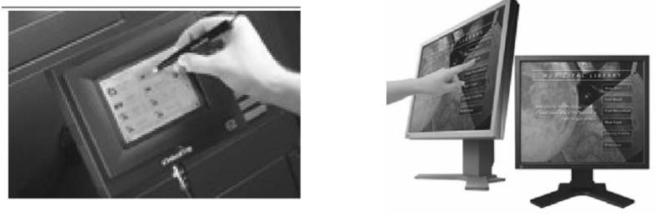
Figure 2.6: Touch Panels

Light Pen
A Light pen is a pointing device shaped like a pen and is connected to the computer. The tip of the light pen contains a light-sensitive element (photoelectric cell) which, when placed against the screen, detects the light from the screen enabling the computer to identify the location of the pen on the screen. It allows the user to point to displayed objects, or draw on the screen, in a similar way to a touch screen but with greater positional accuracy. A light pen can work with any CRT-based monitor, but not with LCD screens, projectors or other display devices. The light pen actually works by sensing the sudden small

change in brightness of a point on the screen when the electron gun refreshes that spot. By noting exactly where the scanning has reached at that moment, the x, y position of the pen can be resolved. The pen position is updated on every refresh of the screen. Light pens are popularly used to digitize map or engineering drawing or signature or handwriting.
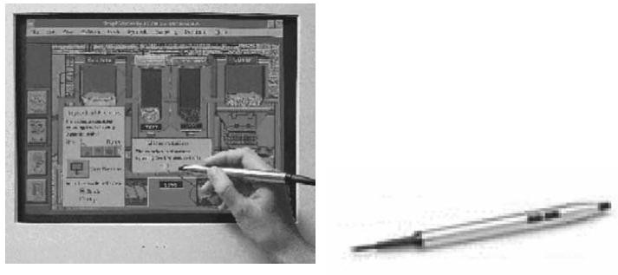

Figure 2.7: Light Pen

Data Glove
The Data glove is an interface device that uses position tracking sensors and fiber optic strands that run down each finger and are connected to a compatible computer; the movement of the hand and fingers are displayed live on the computer monitor which in turn allows the user to virtually touch an object displayed on the same monitor. With the object animated it would appear that the user (wearing the data glove) can pick up an object and do things with it just as he would do with a real object. In modern data glove devices, tactile sensors are used to provide the user with an additional feeling of touch or the amount of pressure or force the fingers or hands are exerting even though the user is not actually touching anything. Thus data glove is an agent to transport the user to virtual reality.

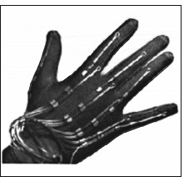

Figure 2.8: Data Glove

Image Scanners
Drawings, graphs, color and black-and-white photos, or text can be stored for computer processing with an image scanner by passing an optical scanning mechanism over the information to be stored. The gradations of gray scale or color are then recorded and stored in an array. Once we have the internal representation of a picture, we can apply transformations to rotate, scale, or crop the picture to a particular screen area. We can also apply various image processing methods to modify the array representation of the picture. For scanned text input, various editing operations can be performed on the stored documents. Some scanners are able to scan either graphical representations or text, and they come in a variety of sizes and capabilities.

Voice-System
The Voice-system or Speech recognition system is a sophisticated input device that accepts voice or speech input from the user and transforms it into digital data that can be used to trigger graphic operations or enter data in specific fields. A dictionary is established for a particular operator (voice) by recording the frequency-patterns of the voice commands (words spoken) and corresponding functions to be performed. Later when a voice command is given by the same operator, the system searches for a frequency-pattern match in the dictionary

and if found the corresponding action is triggered. If a different operator is to use the system then the dictionary has to be re-established with the new operator’s voice patterns.

Hard Copy Devices
Computer Graphics hardcopy is output in a fixed medium that can be taken away from the context in which it was created, and can be communicated to your audience without the original context. There are several ways this can be done, but the basic idea is that any kind of medium that can carry an image is a candidate for hardcopy. These can be physical (paper, sculptural) or digital (images, video). Each of these media has its own issues in terms of its capability and how you must prepare your images for the medium. Creating hardcopy can mean creating a digital record of the work that can be sent to some sort of output device. That device may be actually attached to the computer, such as a printer or a film recorder, or it may be a device to which we communicate data by network, disk, or CD-ROM.

Hard-copy devices are the entities that produce the output which can be retained over the time. That is, nothing but printing over the paper. There are two broad categories of hardcopy devices — one is the printer and the other is the plotter. Though plotters have limited and specialized uses, printer is a common yet important accessory of any computer system, specially for a graphics system. Most of the computer graphics creations have their ultimate utilizations in printed/plotted forms that are used for design documentation, exhibition or publication in books or other print media. So, it is the quality of printed/plotted output that makes computer graphics applications appealing to the businesses it caters to. In keeping with its importance in real life, there have been close competitions amongst the manufacturers in developing newer and cheaper models of hardcopy devices ranging from low cost dot matrix and popular Deskjets to heavy duty Laserjets or sophisticated pen plotters.

Printer
Printers are output devices that convert computer data into printed characters or graphics on paper. It is one of the most commonly used peripheral devices in general business. It is an important accessory of any computer system specially for a graphics system. This is because most of the graphics creation using computer graphics has its ultimate utilization in printed form – for documentation, exhibition or publication in print media or books. It is the quality of printed output that finally matters in many businesses. Based on the available printing technology, the major factors which control the quality of printer are individual dot size on the paper and number of dots per inch (dpi). Clearly, the lesser the size of the dots, the better the detail of the figure reproduced. Higher dpi values increase the sharpness and detail of a figure and enhance the intensity levels that a printer supports. Other important factors for selection of a printer are printing speed and print area or printer memory.

Impact vs. Non-impact
There are several major printer technologies available. These technologies can be broken down into two main categories with several types in each:
- Impact Printer: These printers have a mechanism whereby formed character faces are pressed against an inked ribbon onto the paper in order to create an image. For example, dot matrix printer and line printer.
- Non-impact Printer: These printers do not touch the paper rather use laser techniques, ink sprays, xerographic processes and electrostatic methods to produce the image on paper. For example, laser printer, inkjet printer, electrostatic printer, drum plotter, flatbed plotter.

Dot Matrix Printer
A Dot matrix printer refers to a type of computer printer with a print head (usually containing 9 to 24 pins) that runs back and forth on the page and prints by impact, striking an ink soaked cloth ribbon against the paper, much like a typewriter. Unlike a typewriter or daisy wheel printer, letters are drawn out of a

dot matrix, and thus, varied fonts and arbitrary graphics can be produced. Because the printing involves mechanical pressure, these printers can create carbon copies. The print head normally prints along every raster row of the printer paper and the colour of print is the colour of the ink of the ribbon.
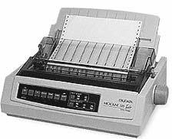
Figure 2.9: Dot Matrix Printer

Each dot is produced by a tiny yet stiff metal rod, also called a ‘wire’ or ‘pin’, which is driven forward by the power of a tiny electromagnet or solenoid, either directly or through small levers (pawls). The pins are usually arranged vertically where marginal offsets are provided between columns to reduce inter-dot spacing. The position of pins in the print head actually limits the quality of such a printer. Hardware improvements to dot matrix printers boosted the carriage speed, added more (typeface) font options, increased the dot density (from 60dpi up to 240dpi), and added pseudo-colour printing through multi colour ribbon. Still such printers lack the ability to print computer-generated images of acceptable quality. It is good for text printing in continuous sheets. Strictly speaking, ‘dot matrix’ in this context is a misnomer, as nearly all inkjet, thermal, and laser printers produce dot matrices. However, in common parlance these are seldom called ‘dot matrix’ printers, to avoid confusion with dot matrix impact printers.

Line Printer
The Line Printer is a form of high speed impact printer in which a line of type is printed at a time. In a typical design, a fixed font character set is engraved onto

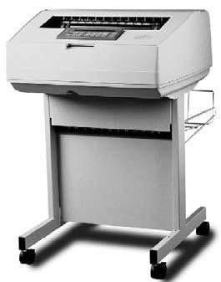
the periphery of a number of print wheels, the number matching the number of columns (letters in a line). The wheels spin at high speed and paper and an inked ribbon are moved past the print position. As the desired character for each column passes the print position, a hammer strikes the paper and ribbon causing the desired character to be recorded on the continuous paper. Printed type is set at fixed positions and a line could consist of any number of character positions with 132 columns as the most common, but 80 column, 128 column and 160 column variants are also in use. Other variations of line printer have the type on moving bars or a horizontal spinning chain. The line printer technology is usually both faster and less expensive (in total ownership) than laser printers. It has its use in medium volume accounting and other large business applications, where print volume and speed is a priority over quality. Because of the limited character set engraved on the wheels and the fixed spacing of type, this technology was never useful for material of high readability such as books or newspapers.
Figure 2.10: Line Printer

Inkjet Printer
An Inkjet printer is a non-impact printer that places extremely small droplets of ink onto the paper to create an image. These printers are popular because they less costly but generate attractive graphic output. The dots sprayed on paper are extremely small (usually between 50 and 60 microns in diameter), and are

positioned very precisely, with resolutions of up to 1440 × 720 dpi. The dots can have different colours combined together to create photo-quality images. The core of an inkjet printer is the print head that contains a series of nozzles that are used to spray drops of ink. The ink is contained in ink cartridges that come in various combinations, such as separate black and colour cartridges, or a cartridge for each ink colour. A stepper motor moves the print head assembly (print head and ink cartridges) back and forth across the paper. The mechanical operation of the printer is controlled by a small circuit board containing a microprocessor and memory. There are two main Inkjet technologies currently used by printer manufacturers.
- Thermal bubble (or Bubble jet): This is used by manufacturers such as Canon and Hewlett Packard. In a thermal inkjet printer, tiny resistors create heat, and this heat vaporizes ink to create a bubble. As the bubble expands, some of the ink is pushed out of a nozzle onto the paper. When the bubble ‘pops’ (collapses), a vacuum is created. This pulls more ink into the print head from the cartridge. A typical bubble jet print head has 300 or 600 tiny nozzles, and all of them can fire a droplet simultaneously.
- Piezoelectric: Patented by Epson, this technology uses piezo crystals. A crystal is located at the back of the ink reservoir of each nozzle. The crystal receives a tiny electric charge that causes it to vibrate. When the crystal vibrates inward, it forces a tiny amount of ink out of the nozzle. When it vibrates out, it pulls some more ink into the reservoir to replace the ink sprayed out.
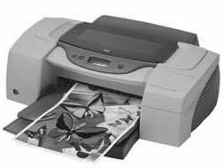
Figure 2.11: Inkjet Printer

Laser Printer
The Laser printer employs technology similar to that of a photocopy machine. A laser beam focuses a positively charged selenium-coated rotating drum. The laser gun removes the positive charge from the drum except for the area to be printed (black portion of the paper). In this way, the laser draws the letters and images to be printed as a pattern of electrical-charges (an electrostatic image). The negatively-charged black toner powder first adheres to this positively- charged area (image) on the drum from where it is transferred to the rolling white paper. Before the paper rolls under the drum, it is given a positive charge stronger than the positive charge of the electrostatic image, so the paper can pull the toner powder away. The paper is then subjected to mild heating to melt and fix the loose toner on the paper. The laser printer is mainly a bilevel printer (i.e. a type of printer that can print only two levels of intensity for each dot which is on or off). In case of colour lasers, this process is repeated three times.

For the printer controller and the host computer to communicate, they need to speak the same page description language. The primary printer languages used nowadays are Hewlett Packard’s Printer Command Language (PCL) and Adobe’s Postscript. Both these languages describe the page in vector form — that is, as mathematical values of geometric shapes, rather than as a series of dots (a bitmap image). Apart from image data, the printer controller receives all of the commands that tell the printer what to do — what paper to use, how to format the page, how to handle the font, etc. Accordingly, the controller sets the text margins, arranges the words and places the graphics. When the page is arranged, the raster image processor (RIP) takes the page data, either as a whole or piece by piece, and breaks it down into an array of tiny dots so the laser can write it out on the photoreceptor drum. In most laser printers, the controller saves all print-job data in its own memory. This lets the controller put different printing jobs into a queue so it can work through them one at a time.

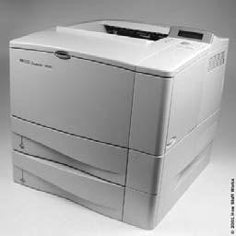

Figure 2.12: LaserJet Printer

Electrostatic Printer
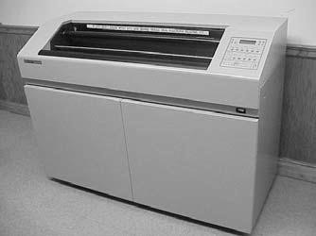
In Inkjet printers, the single printing head moves left-to-right and prints as it is traveling. In contrast, the Electrostatic printer has many print heads, actually covering the entire 36" media width. So, instead of a single print head moving across the width of the media, the electrostatic printer prints an entire width of the page at one time. The media (paper, vellum, film) is electrostatically charged (energized). The toner solution is circulated past the media and ‘sticks’ to the energized portion of the media, thus producing a very fast high quality image. The printer creates colour prints by breaking colour data down into three basic colours (cyan, magenta, and yellow) plus black, and printing one colour at a time. In 5-pass print mode, combinations of cyan, magenta, yellow and black provide a wide range of different colours. Using the registration marks printed during the preliminary registration pass ensures that the colour plot is beautiful with no misalignment.
Figure 2.13: Electrostatic Printer

Dye-Sublimation Printer
A Dye-Sublimation Printer is a computer printer which uses heat to transfer dye onto materials such as a plastic, card, paper, or fabric. Dye sublimation printers (also known as "Dye Diffusion Thermal Transfer Printers") are known for their high quality photographic output. As the technology continues to be improved, dye sublimation printers are bringing cost-effective high quality digital printing into the mainstream. Dye sublimation printing starts with films that contain dyes which will either be a single four layered film with cyan, magenta, yellow, and gray pigments or four separate films for each color. Because the films contain the pigments, they will appear red, blue, green, and gray. During the printing process, the films are placed on the paper and heated up by the print head. This will cause the pigments to leave the film and enter into the paper where it cools re-solidifies. This is the "sublimation" part. Sublimation means to heat something and turn it into a vapor, then to form it back into a solid. Because the pigments go from solid, to gas, and back to solid, there is little mess compared to ink. There are two factors that contribute to the quality of dye sub printers. The first is continuous tone, and the other is un-dithered color.

In Continuous tone, the color produced by a dye-sub is the result of the mixing of pigments to get the actual color. This is in contrast to most other printing methods which use a tight group of colored dots which when seen by the human eye from a distance, appear to be a color (a process known as "dithering"). Under magnification, the dots are clearly different colors, and when seen close up with the naked eye, the picture appears grainy. Because only one color needs to be printed (instead of up to four), a dye sub can place more dots on a paper. It takes a 1200 dpi printer to get the resolution a 300 dpi dye-sub printer is capable of.

In Un-dithered color, the color sublimes on the paper instead of being laid down as little dots and this make the edges of each pixel to be blurred. This gives the impression of blending for a more natural appearance. Dots from an inkjet leave large white gaps in between pixels, giving the impression of a grain. It is also comforting to know that because dyes sublimate into the paper instead of just

being painted onto its surface, dye sub prints tend to resist fading and are often colorfast. Using special dyes and papers allow them to last even longer.
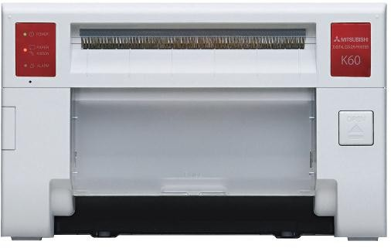
Fig 2.14: Dye-Sublimation Printer

Plotter
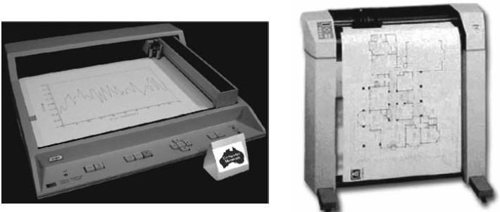
In contrast to the printer which is primarily a raster scan device, the Plotter is a vector device. In colour plotters, the carriage accommodates a number of pens with varying colours and widths. The microprocessor in the plotter receives instructions from the host computer and executes commands like ‘move’ (moving the carriage to a given position with pens up) and ‘draw’ (drawing geometric entities like point, line, arc, circle etc. with pens down). Since the plotter is a vector device, it can directly reach specific positions on printer paper without following raster row sequence. In Flat Bed Plotter, the paper lies flat and stationary while the pen moves from one location to another on the paper. But in Drum Plotters, the paper itself slides on a cylindrical drum and the pen moves over the drum.

Fig. 2.15: Flatbed Plotter and Drum Plotter

Display Devices
A Display (or Soft Copy) device is an output device for presentation of information in visual or tactile form. The display medium for computer graphic- generated pictures has become widely diversified. Typical examples are CRT- based display, Liquid Crystal, LED and Plasma based display and stereoscopic display. CRT display is by far the most common display technology and most of the fundamental display concepts are embodied in CRT technology.

VIDEO
Just like text, audio and still image, digital videos are also powerful elements of multimedia systems. Basically video or motion pictures are created by displaying images depicting progressive stages of motion at a rate fast enough so that the projection of individual images overlap on the eye. Persistence of vision of human eye, which allows any projected image to persist for 40–50 ms, requires a frame rate of 25–30 frames per second to ensure perception of smooth motion picture. In a video display:
- Horizontal resolution is the number of distinct vertical lines that can be produced in a frame.
- Vertical resolution is the number of horizontal scan lines in a frame.
- Aspect ratio is the width-to-height ratio of a frame.
- Interface ratio is the ratio of the frame rate to the field rate.

There are three types of video signals: Component video, Composite video and S- video. Most computer systems and high-end video systems use component video whereby three signals R, G and B are transmitted through three separate wires corresponding to red, green and blue image planes respectively. However, because of the complexities of transmitting the three signals of component video in exact synchronism and relationship, these signals are encoded using a frequency interleaving scheme into a composite format that can be transmitted

through a single cable. Such format known as composite video, used by most video systems and broadcast TV, uses one luminance and two chrominance signals. Luminance (Y) is a monochrome video signal that controls only the brightness of an image. Chrominance is actually two signals (I and Q or U and V), called colour differences (B–Y, R–Y) and contains colour information of an image. Each chrominance component is allocated half as much band width as the luminance, a form of analog data compression, which is justified by the fact that human eyes are less sensitive to variations in colour than to variations in brightness. Theoretically, there are infinite possible combinations (additive) of R, G, B signals to produce Y, I, Q or Y, U, V signals.

Unlike composite video, S-video (separated video or super video or S –VHS) uses two wires, one for luminance and another for a composite chrominance signal. Component video gives the best output since there is no cross-talk or interference between the different channels unlike composite video or S-video.
In a television transmission system, every part of every moving image is converted into analog electronic signals and is transmitted. The VCR can store TV signal on magnetic tapes, which can be played to reproduce stored images. There are three main standards for analog video signals used in television transmission: NTSC (National Television Standards Committee), SECAM (Systeme Electronique Couleur Avec Memoire), and PAL (Phase Alternate Line).

Digital Video
For video to be played and processed in computers, it needs to be converted from analog to digital representation. Video digitization is achieved just like audio digitization by sampling the analog video signal at a preset frequency and subsequently quantizing the discrete samples in digital format. This is done with the help of analog to digital converter (ADC). There are two kinds of possible digitizations or digital coding–Composite coding and Component coding.

In Composite coding, all signal components taken together as a whole are converted into digital format. In component coding, each signal component is digitized separately using different sampling frequency (13.5 MHz for luminance, 6.75 MHz for chrominance). Based on whether the analog to digital converter (ADC) is inside a digital camera, or in an external unit or inside the computer, there can be three types of digital video systems – Digital Camera-based System, External ADC System and Video Frame Grabber Card-based System. The main function of the video frame grabber card is to take the composite (luminance- chrominance) analog video signal, decode it to RGB signal, then convert it to the digital format and store each frame first in the frame buffer on the card itself. At an adequate frame-rate, consecutive frames are streamed to the monitor, routed through the frame buffer of the main memory to present live video on the computer screen. The Sun video digitizer from Sun Microsystems captures NTSC video signal (RGB) with frame resolution of 320 × 240 pixels, quantization of 8 bits/pixels and a frame rate of 30 frames per second. The digital video approximates the original analog video and depends on the sampling resolution or number of bits used to represent any pixel value.

Advantages of Digital Video
- Storing video on digital devices memory ready to be processed, (noise removal, cut and paste, size and motion control and so on) and integrated into various multimedia applications is possible.
- It allows direct access, which makes non-linear video editing (audio mixing, adding text, titles and digital effects etc.) simple.
- It allows repeated recording without degradation of image quality.
- Ease of encryption and better tolerance to channel noise is possible.

Digital Video Standards
To improve the picture quality and transmission efficiency, new generation televisions systems are designed based on international standards that exploit the advantage of digital signal processing. These standards include High

Definition Television or HDTV, Improved Definition Television or IDTV, Double Multiplexed Analog Components or D2-MAC, Advanced Compatible Television, and First System or ACTV-I. HDTV standard that support progressive (non- interlaced) video scanning; has much wider aspect ratio (16:9 instead of 4:3); greater field of view; higher horizontal and vertical resolution (9600 and 675 respectively in USA) and more bandwidth (9 MHz in USA) as compared to conventional colour TV systems.

Video Editing Software
For building multimedia applications, digitized video is often required to be edited using specialized software. Adobe Premiere is a popular mid-range non- linear video editing application that provides some post-production facilities on desktop platform. Three windows are used by Premiere namely Project, Timeline and Monitor. Project window is used for importing and displaying raw video and audio clips and still images with all relevant information. The timeline window provides a visual display of the linear extent of the completed movie, showing the order of its component clips. It uses multiple audio and video tracks for transitions and overlays. Audio and video clips can be dragged from the project window and dropped on the timeline for assembly. The monitor window is used for editing and viewing the video frames. Editing includes trimming, overlaying, applying effects like dissolve, wipes, spins and page turns for transition of one clip to another. Serious post production operations (changes) like colour and contrast corrections, blurring or sharpening of images, element insertion and compositing, applying filter to a clip and vary it over time, sophisticated interpolation between key frames and so on can be done with more control and perfection by using dedicated post-production software like Adobe After Effects.

Classifications of Display Devices
The most prominent part in a personal computer is the display system that makes graphic display possible. The display system may be attached to a PC to display character, picture and video outputs. Some of the common types of display systems available in the market are:
- Raster Scan Displays
- Random Scan Displays
- Direct View Storage Tube
- Flat Panel Displays
- Three Dimensional Viewing Devices
- Stereoscopic and Virtual Reality System

The Display systems are often referred to as Video Monitor or Video Display Unit VDU). The most common video monitor that normally comes with a PC is the Raster Scan type. However, every display system has three basic parts – the display adapter that creates and holds the image information, the monitor which displays that information and the cable that carries the image data between the display adapter and the monitor..

Raster Scan Display
This type of display basically employs a Cathode Ray Tube (CRT) or LCD Panel for display. The CRT works just like the picture tube of a television set. Its viewing surface is coated with a layer of arrayed phosphor dots. At the back of the CRT is a set of electron guns (cathodes) which produce a controlled stream of electrons (electron beam). The phosphor material emits light when struck by these high-energy electrons. The frequency and intensity of the light emitted depends on the type of phosphor material used and energy of the electrons. To produce a picture on the screen, these directed electron beams start at the top of the screen and scan rapidly from left to right along the row of phosphor dots. They return to the left-most position one line down and scan again, and repeat

this to cover the entire screen. The return of the beam to the leftmost position one line down is called horizontal retrace during which the electron flow is shut off. In performing this scanning or sweeping type motion, the electron guns are controlled by the video data stream that comes into the monitor from the video card and this varies the intensity of the electron beam at each position on the screen. The instantaneous control of the intensity of the electron beam at each dot is what controls the colour and brightness of each pixel on the screen. All this happens very quickly, and the entire screen is drawn in a fraction (say, 1/60th) of a second. An image in raster scan display is basically composed of a set of dots and lines; lines are displayed by making those dots bright (with the desired colour) which lie as close as possible to the shortest path between the endpoints of a line.

Refresh Rate and Interlacing
When a dot of phosphor material is struck by the electron beam, it glows for a fraction of a second and then fades. As brightness of the dots begins to reduce, the screen-image becomes unstable and gradually fades out. In order to maintain a stable image, the electron beam must sweep the entire surface of the screen and then return to redraw it a number of times per second. This process is called refreshing the screen. After scanning all the pixel-rows of the display surface, the electron beam reaches the rightmost position in the bottommost pixel line. The electron flow is then switched off and the vertical deflection mechanism steers the beam to the top left position to start another cycle of scanning. This diagonal movement of the beam direction across the display surface is known as vertical retrace. If the electron beam takes too long to return and redraw a pixel, the pixel will begin to fade; it will return to full brightness only when redrawn. Over the full surface of the screen, this becomes visible as a flicker in the image, which can be distracting and hard on the eyes.

In order to avoid flicker, the screen image must be redrawn fast enough so that the eye cannot tell that refresh is going on. The refresh rate is the number of

times per second that the screen is refreshed. It is measured in Hertz (Hz), the unit of frequency. The refresh rates are somewhat standardized; common values are 56, 60, 65, 70, 72, 75, 80, 85, 90, 95, 100, 110 and 120 Hz. Though higher
refresh rates are preferred for better comfort in viewing the monitor, the maximum refresh rate possible depends on the resolution of the image. The maximum refresh rate that a higher resolution image can support is less than that supported by a lower resolution image, because the monitor has more number of pixels to cover with each sweep. Actually, support for a given refresh rate requires two things: a video card capable of producing the video images that many times per second, and a monitor capable of handling and displaying that many signals per second. Every monitor should include, as part of its specification, a list of resolutions it supports and the maximum refresh rate for each resolution. Many video cards now include setup utilities that are pre- programmed with information about different monitors. When you select a monitor, the video card automatically adjusts the resolutions and respective allowable refresh rates. Windows 95 and later versions extend this facility by supporting Plug and Play for monitors; you plug the monitor in and Windows will detect it, set the correct display type and choose the optimal refresh rate automatically.

Some monitors use a technique called interlacing to cheat a bit and allow themselves to display at a higher resolution than is otherwise possible. Instead of refreshing every line of the screen, when in an interlaced mode, the electron guns sweep alternate lines on each pass. In the first pass, odd-numbered lines are refreshed, and in the second pass, even numbered lines are refreshed. This allows the refresh rate to be doubled because only half the screen is redrawn at a time. The usual refresh rate for interlaced operation is 87Hz, which corresponds to 43.5 Hz of ‘real’ refresh in half-screen interlacing.

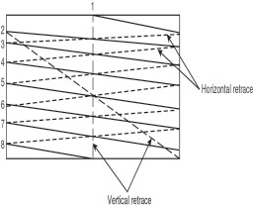
Fig. 2.16: Schematic Diagram of an Interlaced Raster Scan

In the Figure above, the odd-numbered lines represent scanning one half of the screen and the even-numbered lines represent scanning of the other half. There are two separate sets of horizontal and vertical retrace.

CRT (Cathode Ray Tube)
A CRT is similar to a big vacuum glass bottle. It contains three electron guns that emit a focused beam of electrons, deflection apparatus (magnetic or electrostatic), which deflects these beams both up and down and sideways, and a phosphor-coated screen upon which these beams impinge. The vacuum is necessary to let those electron beams travel across the tube without running into air molecules that could absorb or scatter them.

The primary component in an electron gun is a cathode (negatively charged) encapsulated by a metal cylinder known as the control grid. A heating element inside the cathode causes the cathode to be heated as current is passed. As a result, electrons ‘boil-off’ the hot cathode surface. These electrons are accelerated towards the CRT screen by a high positive voltage applied near the screen or by an accelerating anode. If allowed to continue uninterrupted, the naturally diverging electrons would simply flood the entire screen. The cloud of electrons is forced to converge to a small spot as it touches the CRT screen by a focusing system using an electrostatic or magnetic field. Just as an optical lens focuses a

beam of light at a particular focal distance, a positively charged metal cylinder focuses the electron beam passing through it on the centre of the CRT screen. A pair of magnetic deflection coils mounted outside the CRT envelope deflects the concentrated electron beam to converge at different points on the screen in the process of scanning. Horizontal deflection is obtained by one pair of coils and vertical deflection by the other pair and the deflection amount is controlled by adjusting the current passing through the coils. When the electron beam is deflected away from the centre of the screen, the point of convergence tends to fall behind the screen resulting in a blurred (defocused) display near the screen edges. In high-end display devices this problem is eliminated by a mechanism which dynamically adjusts the beam focus at different points on the screen.
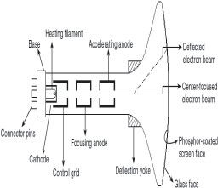
Fig 2.17: Schematic Diagram of a Raster Scan CRT
When the electron beam converges on to a point on the phosphor-coated face of the CRT screen, the phosphor dots absorb some of the kinetic energy from the electrons. This causes the electrons in the phosphor atoms to jump to higher energy orbits. After a short time, these excited electrons drop back to their earlier stable state, releasing their extra energy as small quantum of light energy. As long as these excited electrons return to their stable state, phosphor continues to glow (phosphorescence) but gradually loses brightness. The time between the removal of excitation and the moment when phosphorescence has decayed to 10 per cent of the initial brightness is termed as persistence of phosphor. The brightness of the light emitted by phosphor depends on the intensity with which

the electron beam (number of electrons) strikes the phosphor. The intensity of the beam can be regulated by applying measured negative voltage to the control grid. Corresponding to a zero value in the frame buffer, a high negative voltage is applied to the control grid, which in turn will shut off the electron beam by repelling the electrons and stopping them from coming out of the gun and hitting the screen. The corresponding points on the screen will remain black. Similarly, a bright white spot can be created at a particular point by minimising the negative voltage at the control grid of the three electron guns when they are directed to that point by the deflection mechanism.

Apart from brightness, the size of the illuminated spot created on the screen varies directly with the intensity of the electron beam. As the intensity or number of electrons in the beam increases, the beam diameter and spot size increases. Also the highly excited bright phosphor dots tend to spread the excitation to the neighbouring dots thereby further increasing the spot size. Therefore the total number of distinguishable spots (pixels) that can be created on the screen depends on the individual spot size. The lower the spot size, the higher the image resolution.

In a monochrome CRT there is only one electron gun, whereas in a colour CRT there are three electron guns each controlling the display of red, green and blue light respectively. Unlike the screen of a monochrome CRT, which has a uniform coating of phosphor, the colour CRT has three colour-phosphor dots (dot triad) – red, green and blue – at each point on the screen surface. When struck by an electron beam, the red dot emits red light, the green dot emits green light and the blue dot emits blue light. Each triad is arranged in a triangular pattern, as are the three electron guns. The beam deflection arrangement allows all the three beams to be deflected at the same time to form a raster scan pattern. There are separate video streams for each RGB (red, green and blue) colour components which drive the electron guns to create different intensities of RGB colours at each point on the screen.

To ensure that the electron beam emitted from individual electron guns strikes only the correct phosphor dots (e.g., the electron gun for red colour excites only the red phosphor dot), a shadow mask is used just before the phosphor screen. The mask is a fine metal sheet with a regular array of holes punched in it. The mask is so aligned that as the set of three beams sweeps across the shadow mask, they converge and intersect at the holes and then hit the correct phosphor dot; the beams are prevented or masked from intersecting other two dots of the triad. Thus, different intensities can be set for each dot in a triad and a small colour spot is produced on the screen as a result.

Bit Planes, Colour Depth and Colour Palette
The appearance and colour of a pixel of an image is a result of intersection of three primary colours (red, green and blue) at different intensities. When the intensities of all three electron beams are set to the highest level (causing each dot of a triad to glow with maximum intensity), the result is a white pixel; when all are set to zero, the pixel is black. And for many different combinations of intermediate intensity levels, several million colour pixels can be generated.
For a mono monitor using a single electron gun, the phosphor material can glow with varied intensities depending on the intensity of the electron beam. As a result, a pixel can be black (zero intensity) or white (maximum intensity) or have different shades of grey. The number of discrete intensities that the video card is capable of generating for each primary colour determines the number of different colours that can be displayed. The number of memory bits required to store colour information (intensity values for all three primary colour components) about a pixel is called colour depth or bit depth. A minimum of one memory bit (colour depth = 1) is required to store intensity value either 0 or 1 for every screen point or pixel. Corresponding to the intensity value 0 or 1, a pixel can be black or white respectively. So, if there are n pixels in an image, a total of n-bits of memory used for storing intensity values will result in a pure black and white image. The block of memory which stores (or is mapped with) bi-level intensity

values for each pixel of a full-screen pure black and white image is called a bit plane or bitmap.

Colour or grey levels can be achieved in the display using additional bit planes. First consider a single bit plane – a planar array of bits, with one bit for each screen pixel. This plane is replicated as many times as there are bits per pixel, placing each bit plane behind its predecessor. Hence, the result for n-bits per pixel (colour depth = n) is a collection of n bit planes that allows specifying any one of 2n colours or grey shades at every pixel.

The more the number of bits used per pixel, the finer the colour detail of the image. However, increased colour depths also require significantly more memory for storage, and also more data for the video card to process, which reduces the allowable refresh rate.

For true colour, three bytes of information are used, one each of the red, blue and green signals that make a pixel. A byte can hold 256 different values and so 256 voltage settings are possible for each electron gun which means that each primary colour can have 256 intensities, allowing over 16 million (256 × 256 × 256) colour possibilities. This allows for a very realistic representation of the images, without necessitating any colour compromise. In fact, 16 million colours are more than the human eye can discern. True colour is a necessity for those involved in high quality photo editing, graphical design, etc.

For high colour, two bytes of information are used to store the intensity values for all three colours. This is done by dividing 16 bits into 5 bits for blue, 5 bits for red and 6 bits for green. This means 32 (= 25) intensities for blue, 32 (= 25) for red, and 64 (= 26) for green. This reduced colour precision results in a loss of visible image quality, but one cannot easily see the difference between true colour and high colour image. However, high colour is often used instead of true colour

because high colour requires 33 per cent (or 50 per cent in some cases) less memory and also image generation is faster.
In 256-colour mode, the PC uses only 8 bits; this means something like 2 bits for blue and 3 each for green and red. There are chances that most of the colours of a given picture are not available, and choosing between only 4 (= 22) or 8 (= 23) different values for each primary colour would result in rather blocky or grainy look of the displayed image. A palette or look-up table is used here. A palette is a separate memory block (in addition to the 8 bit plane) created containing 256 different colours. The intensity values stored therein are not constrained within the range 0 to 3 for blue and 0 to7 each for green and red. Rather each colour is defined using the standard 3-byte colour definition that is used in true colour. Thus, the intensity values for each of the three primary colour components can be anything between 0 and 255 in each of the table entries. Upon reading the bit planes, the resulting number instead of directly specifying the pixel colour, is used as a pointer to the 3-byte colour value entry in the look-up table. For example, if the colour number read from the bit planes is 10 for a given pixel, then the intensities of red, green and blue to be displayed for that pixel will be found in the 10th entry of the table. So the full range of true colour can be accessed, but only 256 of the available 16 million colours can be used at a time.

The palette is an excellent compromise at the cost of moderate increase in memory: it allows only 8 bits of the frame buffer to be used to specify each colour in an image and allows the creator of the image to pick any of the 256 colours for the image. This is because the palette can be reloaded any time with different combinations of 256 colours out of 16 million without changing the frame buffer values. Since virtually no image contains an even distribution of colours, this allows for more precision in an image by using more colours than would be possible by assigning each pixel a 2-bit value for blue and 3-bit value each for green and red. For example, an image of the sky with clouds (like the Windows

95 standard background) would have different shades of blue, white and gray, and virtually no red, green, yellow and the like.

256-colour is the standard for much of computing, mainly because the higher- precision colour modes require more resource (especially video memory) and are not supported by many PCs. Despite the ability to ‘hand pick’, the 256 colours, this mode produces noticeably worse image quality than high colour.

Frame Buffer and Output Circuitry
In the early days of PCs, the amount of information displayed was less. A screen of monochrome text, for example, needs only about 2KB of memory space. Special parts of the upper memory area (UMA) were dedicated to hold this video data. As the need for video memory increased into the megabyte range, it made more sense to put the memory on the video card itself. In fact, to preserve existing PC design limitations, it was necessary (the UMA does not have the space to hold bigger screen images). The Frame buffer is the video memory (RAM) that is used to hold or map the image displayed on the screen. The amount of memory required to hold the image depends primarily on the resolution of the screen image and also the colour depth used per pixel. The formula to calculate how much video memory is required at a given resolution and bit depth is:

Memory in MB = (X-resolution × Y-resolution × Bits-per-pixel) = (8 × 1024 × 1024)

However one needs more memory than this formula computes. One major reason is that video cards are available only in certain memory configurations (in terms of whole megabytes). For example you cannot order a card with 1.7 MB of memory; you have to use a standard 2MB card available in the market. Another reason is that many video cards, especially high end accelerators and 3D cards use memory for computation as well as for the frame buffer. Thus, they need much more memory than is required strictly to hold the screen image.

Some motherboards designed are to integrate the video chipset into itself and use a part of the system RAM for the frame buffer. This is called unified memory architecture. This is done to save costs. The result is poorer video performance, because in order to use higher resolutions and refresh rates, the video memory needs a higher performance than the RAM normally used for the system. This is also the reason why video card memory is so expensive compared to regular system RAM. In order to meet the increasing demand for faster and dedicated video memory at a comparable price, a technology was introduced by Intel which is fast becoming a new standard. It is called the Accelerated Graphics Port or AGP. The AGP allows the video processor to access the system memory for graphics calculations, but keeps a dedicated video memory for the frame buffer. This is more efficient because the system memory can be shared dynamically between the system processor and the video processor, depending on the needs of the system. However, it should be remembered that AGP is considered a port – a dedicated interface between the video chipset and the system processor. The display adapter circuitry (on video card or motherboard) in a raster graphics system typically employs a special purpose processor called Display Processor or Graphics Controller or Display Coprocessor which is connected as an I/O peripheral to the CPU.

Random Scan Display
Basically there are two types of CRTs – Raster Scan type and Random Scan type. The main difference between the two is the technique with which the image is generated on the phosphor coated CRT screen. In Raster scan method, the electron beam sweeps the entire screen in the same way you would write a full page text in a notebook, word by word, character by character, from left to right and from top to bottom. In Random scan technique, the electron beam is directed straightaway to the particular point(s) of the screen where the image is to be produced. It generates the image by drawing a set of random straight lines much

in the same way one might move a pencil over a piece of paper to draw an image – drawing strokes from one point to another, one line at a time. This is why this technique is also referred to as vector drawing or stroke writing or calligraphic display.

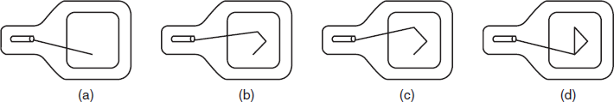
Fig 2.18: Drawing a Triangle on a Random Scan Display
There are of course no bit planes containing mapped pixel values in a vector system. Instead, the display buffer memory stores a set of line drawing commands along with end point coordinates in a display list or display program created by a graphics package. The display processing unit (DPU) executes each command during every refresh cycle and feeds the vector generator with digital x, y and Δx, Δy values. The Vector generator converts the digital signals into equivalent analog deflection voltages. This causes the electron beam to move to the start point or from the start point to the end point of a line or vector. Thus, the beam sweep does not follow any fixed pattern; the direction is arbitrary as dictated by the display commands. When the beam focus must be moved from the end of one stroke to the beginning of the other, the beam intensity is set to
0. Though, the vector-drawn images lack in depth and colour precision, the random displays can work at much higher resolutions than the raster displays. The images are sharp and have smooth edges unlike the jagged edges and lines on raster displays.

Direct View Storage Tube
Direct View Storage Tube (DVST) is rarely used today as part of a display system. However, DVST marks a significant technological change in the usual refresh type display. Both in the raster scan and random scan system, the screen image is maintained (flicker free) by redrawing or refreshing the screen many times per

second by cycling through the picture data stored in the refresh buffer. In DVST, there is no refresh buffer; the images are created by drawing vectors or line segments with a relatively slow-moving electron beam. The beam is designed not to draw directly on phosphor but on a fine wire mesh (called storage mesh) coated with dielectric and mounted just behind the screen. A pattern of positive charge is deposited on the grid, and this pattern is transferred to the phosphor coated screen by a continuous flood of electrons emanating from a separate flood gun.
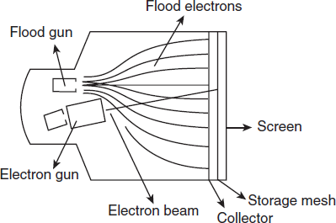
Fig 2.19: Schematic Diagram of a DVST
Just behind the storage mesh is a second grid, the collector, whose main purpose is to smooth out the flow of flood electrons. These electrons pass through the collector at low velocity and are attracted to the positively charged portions of the storage mesh but repelled by the rest. Electrons not repelled by the storage mesh pass right through it and strike the phosphor. To increase the energy of these slow-moving electrons and thus create a bright picture, the screen is maintained at a high positive potential. The storage tube retains the image generated until it is erased. Thus no refreshing is necessary, and the image is absolutely flicker free. A major disadvantage of DVST in interactive computer graphics is its inability to selectively erase parts of an image from the screen. To erase a line segment from the displayed image, one has to first erase the complete image and then redraw it by omitting that line segment. However, the DVST supports a very high resolution which is good for displaying complex images.

Flat Panel Display
To satisfy the need of a compact portable monitor, modern technology has gifted us with LCD panel, Plasma display panel, LED panel and thin CRT. These display devices are smaller, lighter and specifically thinner than the conventional CRT and thus are termed as Flat Panel Display (FPD). FPD in general and LCD panels in particular are most suitable for laptop (notebook) computers but are expensive to produce. Though hardware prices are coming down sharply, cost of the LCD or Plasma monitors is still too high to compete with CRT monitors in desktop applications. However, the thin CRT is comparatively economical. To produce a thin CRT the tube length of a normal CRT is reduced by bending it in the middle. The deflection apparatus is modified so that electron beams can be bent through 90 degrees to focus on the screen and at the same time can be steered up and down and across the screen.
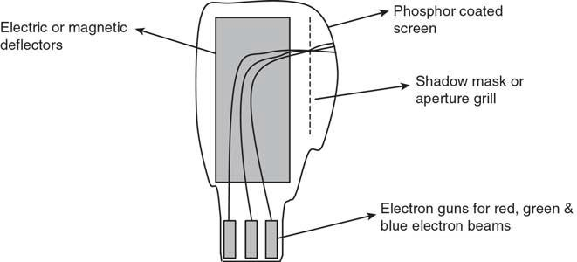
Fig 2.20: Thin CRT

LCD
LCD basically consists of a layer of liquid crystal, sandwiched between two polarizing plates. The polarizers are aligned perpendicular to each other (one vertical and the other horizontal), so that the light incident on the first polarizer will be blocked by the second. This is because a polarizer plate only passes

photons (quanta of light) with their electric fields aligned parallel to the polarizing direction of that plate.

The LCD displays are addressed in a matrix fashion. Rows of matrix are defined by a thin layer of horizontal transparent conductors, while columns are defined by another thin layer of vertical transparent conductors; the layers are placed between the LCD layer and the respective polarizer plate. The intersection of the two conductors defines a pixel position. This means that an individual LCD element is required for each display pixel, unlike a CRT which may have several dot triads for each pixel.

The liquid crystal material is made up of long rod-shaped crystalline molecules containing cyanobiphenyl units. The individual polar molecules in a nematic (spiral) LC layer are normally arranged in a spiral fashion such that the direction of polarization of polarized light passing through it is rotated by 90 degrees. Light from an internal source (backlight) enters the first polarizer (say horizontal) and is polarized accordingly (horizontally). As the light passes through the LC layer it is twisted 90 degrees (to align with the vertical) so that it is allowed to pass through the rear polarizer (vertical) and then reflect from the reflector behind the rear polarizer. When the reflected light reaches the viewer’s eye travelling in the reverse direction, the LCD appears bright.

When an electric current is passed through the LCD layer, the crystalline molecules align themselves parallel to the direction of light and thus have no polarizing effect. The light entering through the front polarizer is not allowed to pass through the rear polarizer due to mismatch of polarization direction. The result is zero reflection of light and the LCD appears black. In a colour LCD, there are layers of three liquid crystal panels, one on top of another. Each one is filled with a coloured (red, green or blue) liquid crystal. Each one has its own set of horizontal and vertical conductors. Each layer absorbs an adjustable portion

of just one colour of the light passing through it. This is similar to how colour images are printed. The principal advantage of this design is that it helps create as many screen pixels as intersections, thus making higher-resolution LCD panels possible. In the true sense, each pixel comprises three colour cells or sub-pixel elements. The image painting operation in LCD panels is different from that of the CRT though both are of raster scan type. In a simple LCD panel, an entire line of screen pixels is illuminated at one time. The process continues to the next line and so on till the entire screen image is completed. Picture definitions are stored in a refresh buffer and the screen is refreshed typically at the rate of 60 frames per second. Once set, the screen pixels stay at fixed brightness until they are reset. The time required to set the brightness of a pixel is high compared to that of the CRT. This is why LCD panel pixels cannot be turned on or off anywhere near the rate at which pixels are painted on a CRT screen. Except the high quality Active Matrix LCD panels, others have trouble displaying movies, which require quick refreshing.

Plasma Panel
Here a layer of gas (usually neon) is sandwiched between two glass plates. Thin vertical (column) strips of conductor run across one plate, while horizontal (row) conductors run up and down the other plate. By applying high voltage to a pair of horizontal and vertical conductors, a small section of the gas (tiny neon bulb) at the intersection of the conductors breaks down into glowing plasma of electrons and ions. Thus, in the array of gas bulbs, each one can be set to an ‘on’ (glowing) state or ‘off’ state by adjusting voltages in the appropriate pair of conductors. Once set ‘on’ the bulbs remain in that state until explicitly turned ‘off’ by momentarily reducing the voltage applied to the pair of conductors. Hence no refreshing is necessary. Because of its excellent brightness, contrast and scalability to larger sizes, plasma panel is attractive. Research is on to eliminate the colour-display limitation of such device at low production cost.

Readymade Image Devices
Image Scanner is a graphic device which directly copies images from a paper or photograph and converts it into the digital format for display, storage and graphic manipulations. Traditionally, design and publishing houses have been the prime users of scanners, but the phenomenal growth of Internet has made the scanner more popular among the web designers. Today scanners are becoming affordable tools to the graphic artists and photographers. There are basically three types of scanners – Drum, Flatbed and Sheetfed scanners.

Drum Scanners are the high-end ones, whereas sheetfed scanners are the ordinary type. Flatbed scanners strike a balance between the two in quality as well as price. There are also handheld scanners or bar-code readers which are typically used to scan documents in strips of about 4 inches wide by holding the scanner in one hand and sliding it over the document.

Flatbed Scanner
A Flatbed scanner uses a light source, a lens, a charge-coupled device (CCD) array and one or more analog-to-digital converters (ADCs) to collect optical information about the object to be scanned, and transform it to an image file. A CCD is a miniature photometer that measures incident light and converts that into an analog voltage. When you place an object on the copy board or glass surface (like a copier machine) and start scanning, the light source illuminates a thin horizontal strip of the object called a raster line. Thus, when you scan an image, you scan one line at a time. During the exposure of each raster line, the scanner carriage (optical imaging elements, which is a network of lenses and mirrors) is mechanically moved over a short distance using a motor. The light reflected is captured by the CCD array. Each CCD converts the light to an analog voltage and indicates the grey level for one pixel. The analog voltage is then converted into a digital value by an ADC using 8, 10 or 12 bits per colour.

The CCD elements are all in a row, with one element for each pixel in a line. If you have 300 CCD elements per inch across the scanner, you can have a maximum potential optical resolution of 300 pixels per inch, also referred to as dots per inch (dpi). There are two methods by which the incident white light is sensed by the CCD. The first involves a rapidly rotating light filter that individually filters the red, green and blue components of the reflected light which are sensed by a single CCD device. Here, the colour filter is fabricated into the chip directly. In the second method, a prismatic beam splitter first splits the reflected white light and three CCDs are used to sense the red, green and blue light beams. Another imaging array technology that has become popular in inexpensive flatbed scanners is contact image sensor (CIS). CIS replaces the CCD array, mirrors, filters, lamp and lens with rows of red, green and blue light emitting diodes (LEDs). The image sensor mechanism, consisting of 300 to 600 sensors spanning the width of the scan area, is placed very close to the glass plate that the document rests upon. When the image is scanned, the LEDs combine to provide white light. The illuminated image is then captured by the row of sensors. CIS scanners are cheaper, lighter and thinner, but do not provide the same level of quality and resolution found in most CCD scanners. The output of a scanner is a bitmap image file, usually in a PCX or JPG format. If you scan a page of text, it may be saved as an image file which cannot be edited in a word processing software. Optical Character Recognition (OCR) software are intelligent programs which can convert a scanned page of text into editable text either into a plain text file, a Word document or even an Excel spreadsheet which can be easily edited. OCR can also be used to scan and recognize printed, typewritten or even handwritten text. The OCR software requires a raster image as an input, which may be an existing image file or an image transferred from a scanner. OCR analyzes the image to find blocks of image information that resemble possible text fields and creates an index of such areas. The software examines these areas, compares shape of each object with a database of words categorized by different fonts or typefaces and recognizes individual text characters from the information.

